|  |  |
| --- | --- |
|  | **FPT ACADEMY INTERNATIONAL**  **FPT – APTECH COMPUTER EDUCATION** |

**Centre Name: ACE-HCMC-2-FPT.**

**Address: 590 Cach Mang Thang 8, District 3, Ho Chi Minh City, Viet Nam.**

**[**Madam’s Boutique**]**

|  |  |  |
| --- | --- | --- |
| **Supervisor:** | Phạm Thị Lánh | |
| **Batch No:** | T1.2108.A0 | |
| **Group No:** | Group 2 | |
| **Serial no:** | **Student name** | **Enrolment Number** |
| 1. | Trần Nhật Tân | Student1323263 |
| 2. | Nguyễn Văn Hiếu | Student1328428 |
| 3. | Đặng Trương Mạnh Kiên | Student1331711 |
| 4. | Đặng Phước Thịnh | Student1331710 |

December 2021

This is to certify that

Mr./Ms: Trần Nhật Tân

Nguyễn Văn Hiếu

Đặng Trương Mạnh Kiên

Đặng Phước Thịnh

Has successfully Designed & Developed

Phạm Thị Lánh

Submitted by :

Date of issue:

Authorized Signature:

Contents

1 ACKNOWLEDGEMENT ............................................................................................................ 5

2 SYNOPSIS...................................................................................................................................... 6

3 REVIEW 1 ..................................................................................................................................... 7

3.1 REQUIREMENT SPECIFICATION.................................................................................. 8

3.2 PROBLEM DEFINITION.................................................................................................... 9

3.3 CUSTOMERS REQUIREMENT SPECIFICATION (CRS)............................................ 9

3.4 ARCHITECTURE & DESIGN OF THE SYSTEM......................................................... 12

3.5 SITEMAP............................................................................................................................. 13

3.6 WEBSITE LAYOUT........................................................................................................... 14

3.6.1 HOMEPAGE................................................................................................................. 14

3.6.2 CONTACT US .............................................................................................................. 16

3.7 TASK SHEET 1................................................................................................................... 18

4 REVIEW 2 ................................................................................................................................... 19

5 PROJECT SNAPSHOTS............................................................................................................ 20

5.1 Home Page............................................................................................................................ 20

5.2 Product details Page ............................................................................................................ 21

5.3 Contact Us:........................................................................................................................... 22

5.4 Footer.................................................................................................................................... 23

6 SOURCE CODE WITH COMMENT....................................................................................... 23

7 USER MANUAL ......................................................................................................................... 25

7.1 System Requirements:......................................................................................................... 25

7.2 Step by Step Instructions:................................................................................................... 25

7.2.1 Starting Home Page:...................................................................................................... 25

7.2.2 Using Search bars & Dropdown menu .......................................................................... 26

7.2.3 Browsing Products Gallery:........................................................................................... 28

7.2.4 Product Details Page:..................................................................................................... 29

7.2.5 CTA Buttons – Compare & Download ......................................................................... 31

7.2.6 CTA Buttons – Miscellaneous....................................................................................... 32

7.2.7 Contact Us..................................................................................................................... 33

7.2.8 Contact Us – Email & Geolocation ............................................................................... 33

7.2.9 Footer............................................................................................................................. 34

8 DEVELOPER’S GUIDE............................................................................................................. 35

8.1 Home page............................................................................................................................ 35

8.1.1 Bootstrap layout............................................................................................................. 35

8.1.2 Logo Animation............................................................................................................. 37

8.2 Top Nav Bar......................................................................................................................... 39

8.2.1 Hamburger Menu........................................................................................................... 39

8.2.2 Navbar Auto hide on scroll............................................................................................ 42

8.3 Side Panel / Side navbar...................................................................................................... 43

8.3.1 Search Bar & Searching Algorithm............................................................................... 43

8.3.2 Drop Down Menus........................................................................................................ 47

8.3.3 Side Panel Responsiveness on smaller screen............................................................... 51

8.4 Home Page - Hero Banner – ............................................................................................... 52

8.4.1 Header Text Animation ................................................................................................. 52

8.4.2 Changing Background Image Animation ...................................................................... 55

8.5 Home Page - Main Section.................................................................................................. 57

8.5.1 Main Section – Owl Carousel........................................................................................ 57

8.5.2 Main Section – Gallery with filter buttons– .................................................................. 61

8.5.3 Main Section - Compare & Download Modals – .......................................................... 63

8.6 Side Panel Call To Action Modals...................................................................................... 69

8.7 Product Details Page ........................................................................................................... 72

8.7.1 Youtube embedded promotional videos. ....................................................................... 72

8.7.2 Product detail section..................................................................................................... 74

8.7.3 Rating page.................................................................................................................... 76

8.8 Contact Us Page................................................................................................................... 79

8.8.1 Contact Us - Hero Banner – .......................................................................................... 79

8.8.2 Contact Us – Feedback & Inquiries –............................................................................ 81

8.8.3 Contact Us – Geolocation/Google Map......................................................................... 84

8.9 Footer.................................................................................................................................... 85

8.9.1 Footer – Bootstrap Layout............................................................................................. 85

8.9.2 Footer – Lightbox Gallery ............................................................................................. 88

8.10 Miscellaneous CSS/Animation Modules............................................................................ 92

8.10.1 Hover.css by Ian Lunn................................................................................................... 92

8.10.2 Pin Construction Animation by Nikolay Talanov ......................................................... 93

9 TASK SHEET 2........................................................................................................................... 94

10 CHECKLIST VALIDATION .................................................................................................... 95

11 REFERENCES ............................................................................................................................ 96

1 ACKNOWLEDGEMENT

The world is a better place thanks to people who want to develop and lead others. What makes

it even better are people who share the gift of their time to mentor future leaders. We would

like to acknowledge all those who have given us their support and knowledge sharing in the

making of this project.

We wish to express our gratitude to the e-Project Team at the Head Office in India, who

provided us with guidance and instructions. We would like to thank all the staff members at

the Center in India for providing us the opportunity to work on this project and offering us

their upmost encouragement through out the process.

We would like to express our special thanks of gratitude to our instructor, Mrs. Pham Thi

Lanh at the Aptech Computer Education HCMC for her able guidance and support in

completing our project. We would also like to extend our gratitude to the staff at the Aptech

HCMC office for providing us with all the facility that was required.

Our acknowledgement to several people whom also helped with: the collections of pictures

samples, CSS & JS libraries, the preparation of web development, sample code snippets and

tutorials and they are all thanked for their contributions. Special mentions goes to the

contributors of Bootstrap 4, the contributors and admins for tutorials sites such as W3C

school, Tutorialspoint.com, GeeksforGeeks, and many other learning sites.

And Lastly, to our many friends and family, you should know that your support and

encouragement was worth more than we can express on paper. Thank you to our moms and

dads for breakfasts, lunch and dinners – we could not have finished the project without being

provided with love and daily nourishments.

2 SYNOPSIS

ASKME Ltd. Is a Multi National Company providing Information services to General People

they have been providing information to people through Telephone calls which could include

anything from Pin to Piano. Their major source of income comes from informing the

customers about those products first for which ASKME is getting paid for.

The BOD’s in their annual general meeting proposed that they should launch a website by the

name CELLINFO.com where the user will get all the information about the various cell

phones available in the market of any brand on a click of a Button.

You are supposed to create a website for them with the below mentioned requirement

specifications:

The website is to be developed to provide certain features according to specific requirements

by the management.

The website is to be developed for the Windows Platform using HTML5, JavaScript and

Geolocation. The site should work well in all leading browsers including Chrome, IE, Firefox

etc.

3 REVIEW 1

3.1 REQUIREMENT SPECIFICATION

The Website MB STORE is to be created based on the following requirements:

1. The Home Page should be created making use of sections with a suitable logo.
2. Collection must be made more categorized as per the designers and types of attire.
3. Color combination must be made more précised in the application so that clothes must be properly highlighted.
4. Navigation needs to be smoother.
5. Comparison of different brands must be included in the website.
6. Gallery section of the boutique’s hit collection must be included.
7. The look and feel of the project must be made user friendly and uniformity in the color combination must be maintained.
8. About us, Contact Us (address and map) must be added. Address of the Company should be displayed using GeoLocation API (eg. GoogleMaps).
9. Images must be added with its alt attribute defined.

3.2 PROBLEM DEFINITION

After analyzing the Queries coming in form various Customers mostly are related to

information regarding Women's Fashion which could be one or all of the follow

1) fashion by famous brands

2) market price

3) designer

And many more...

As you can see there are a lot of queries which cannot be answered online or would be very

difficult for the Call executive to explain the entire features of the product which again would

consume a lot of Call time of the executives as well.

Our Website should be able to solve this problem by providing an alternative mean for

customers to seek out information at their own pace. The website will be referred to as self-

serviced website for informational guidance and comparisons.

3.3 CUSTOMERS REQUIREMENT SPECIFICATION (CRS)

1. Client: AskMe Ltd.

2. Objectives:

o Provide a website to display information about products (Women's Fashion) categorizing

product information according to brands and features.

o The website should have soothing color with proper logo and images

o Users should be able to download information from the site to their computers. If users

wish to send us an email or looking for our physical location, users should be able to do

so in “Contact Us” page.

o The keywords are “logo”, “menu”, “images”, “pastel color” “Category

3. Inputs provided by clients:

o Click on clickable links from menu, or search menu.

o Click to clickable links/images in “Products” session to link to third party websites.

o Click “Contact Us” link to link to “Contact Us” webpage.

o Click “send us an email” to send us email.

4. Hardware Requirement:

o A minimum computer system that will help you access all the tools in the courses is a

Pentium 166 or better

o 64 Megabytes of RAM or better

5. Software Requirement:

o Window 7/10 OS or higher

o HTML5/CSS/JS supporting browsers

o Visual Studio Code.

o Bootstrap 4

o JQuery

o Notepad editor

6. Scope of the Work (in brief):

Depending on the decision taken by the management regarding the MB STORE application,

following are the requirements based on which the software needs to be developed:

o Displaying proper Logo, Images, Menu.

o A Web-based GUI to be created for displaying hyperlinks and clickable Images. The

menu will stay on the left side navigation bar, it is to be closed with a toggle button.

The menu will provide links according to phone brands and features. There will be

links to other pages as well as clickable images to direct Users to third party

websites

o A “Contact Us” to be created to provide link to email to users, Our office location will

be displayed using Geolocation API embedded in the HTML.

3.4 ARCHITECTURE & DESIGN OF THE SYSTEM

Client Browsers

MB STORE

Web server

Static

Assets

(pics,logo,

Banner)

CSS Javascripts HTML

Boostrap 4

& JQuery, Ajax HTML 5

Owl Carousel & &

Custom Scrollbar Database

HOME

Category About Contact Us

skirt hand bag jewels

Skirt model hand bag model jewels model

Brand brand brand

Product detail Product detail Product detail

3.6 WEBSITE LAYOUT

The website layout is to be designed with a SIMPLE but ELEGANT design. Because of the objective is

to QUICKLY and SYSTEMICALLY deliver information to the site visitors, the main focus of our

webpage will be on the main landing page where all the information will be stored and represented. The

site users will have a variety of interactions such as performing search function on a search bar, searching

using dropdown menus, comparing phone features, downloading Word documents, links to third party

websites.

The websites will also have a few complimentary pages such as About, Contact Us which contain

introductory information about our team and our office address.

3.6.1 HOMEPAGE

This layout below describes our Home Landing Page which contains three important part:

- The Top navigation bar and Side navigation bar:

There will be two navigation bars to work in synergy.

the side menu is the MOST IMPORTANT part of our project since this is where Users will have the

most interactions. There will be Our company’s logo on top, and several dropdown menu

incorporated within the side panel, a functional search bar, and buttons to link to our Website’s

other pages.

- Main Content:

fashion brands will placed on top of the main content along with a brief description of the

. Next will be several carousel slide that will showcase the phone products and

features. Each carousel will have several product cards which will contain a brief summary of

features and hyperlink buttons.

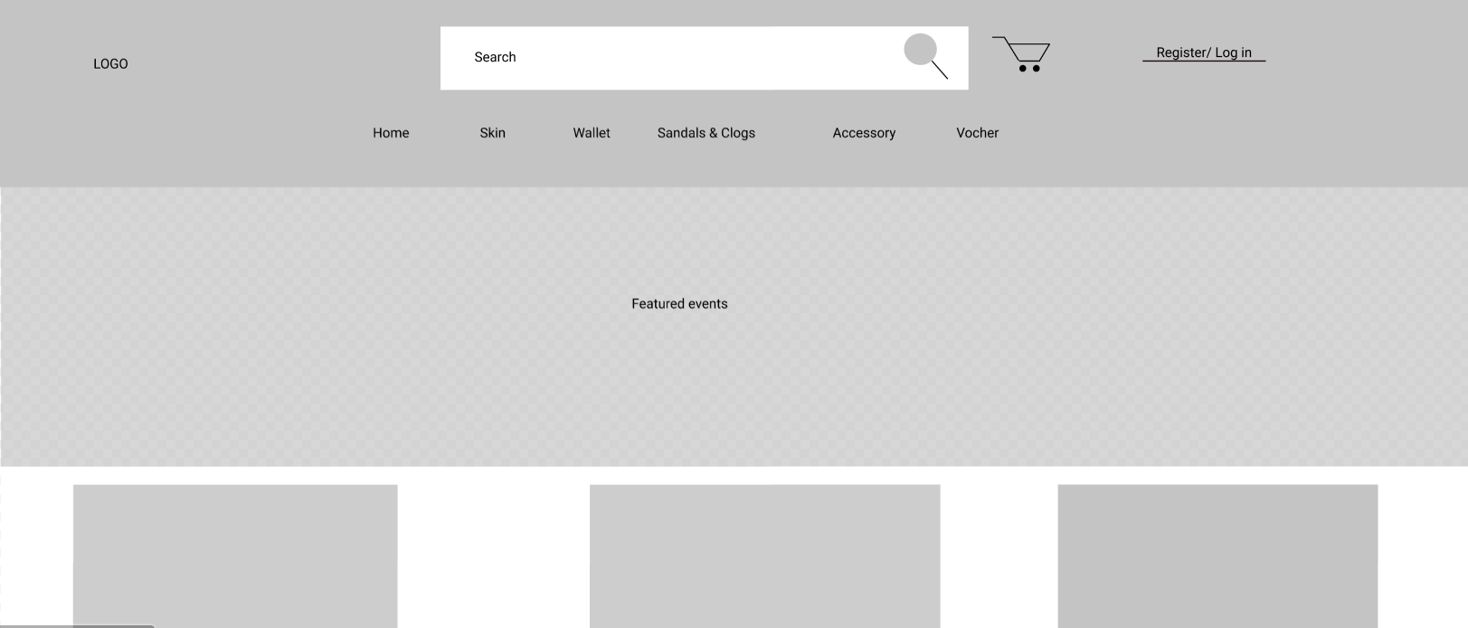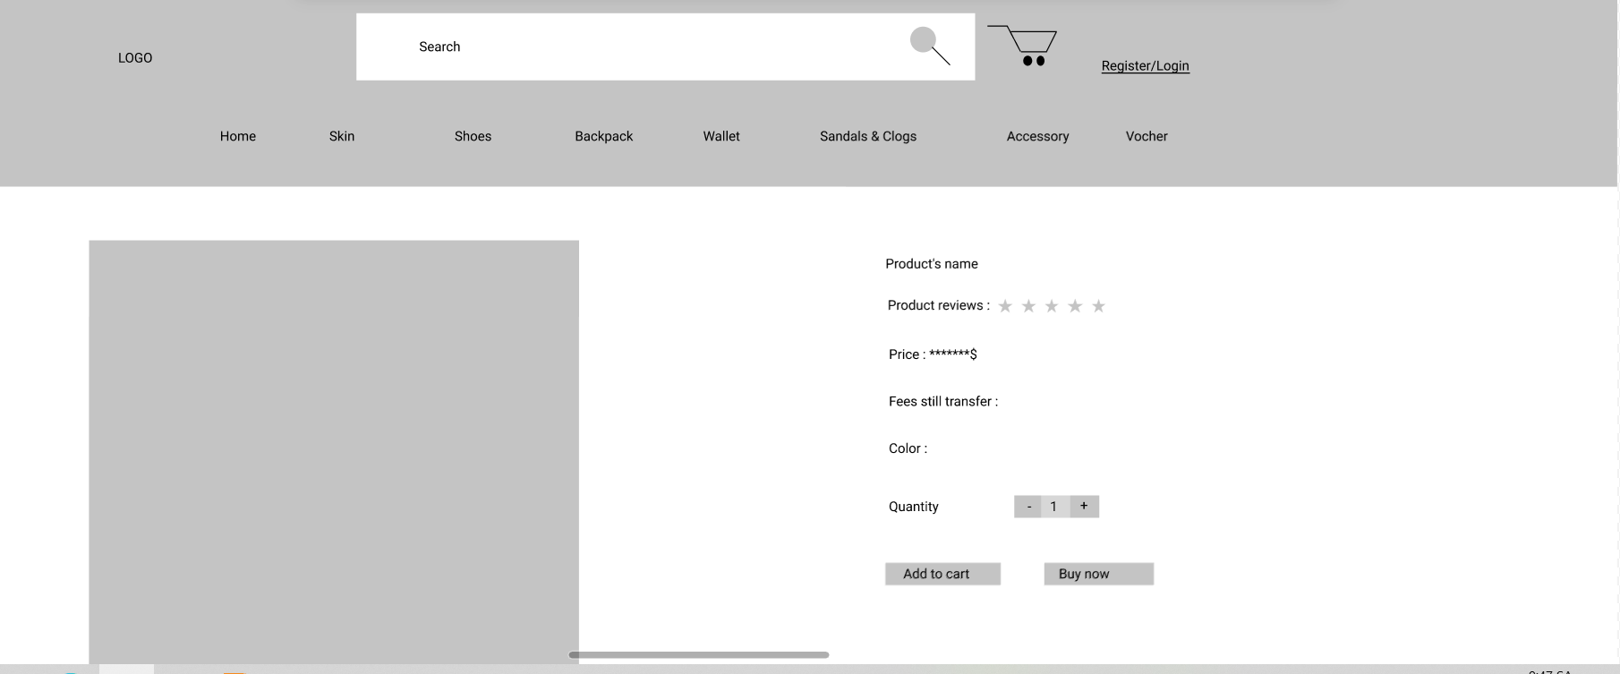

3.6.2 CONTACT US

LOGO Search

Name*

Email*

Phone*

Subject*

Message*

SEND REVIEW 2

**Welcome To Team 2**

Welcome the women to us today. We are pleased to introduce MADAM's Boutique for women's fashion shopping. This is a review of our website.

**1.Home page**

The following snapshots illustrate the creation of MADAM's Boutique.COM home page:

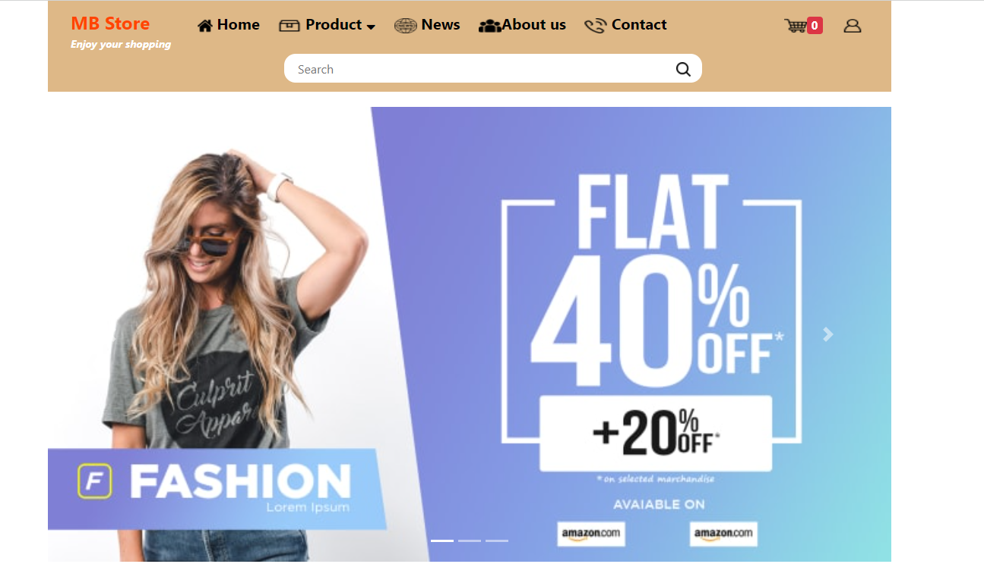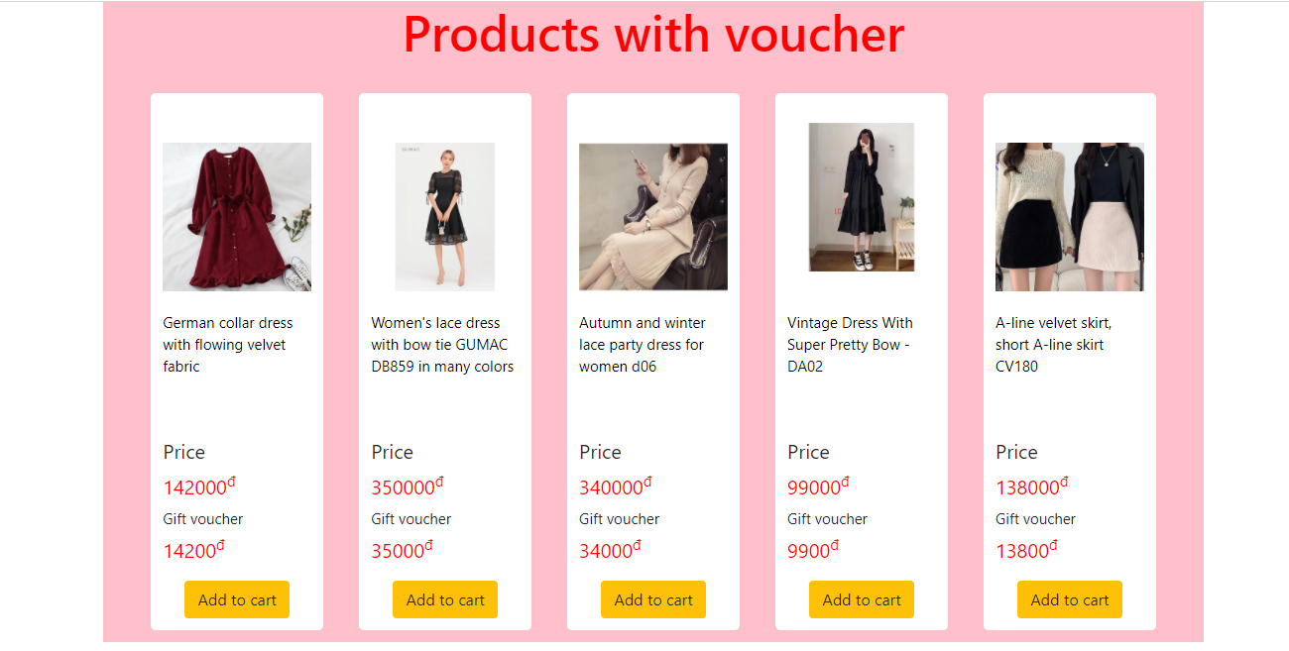

**2. Product details Page**

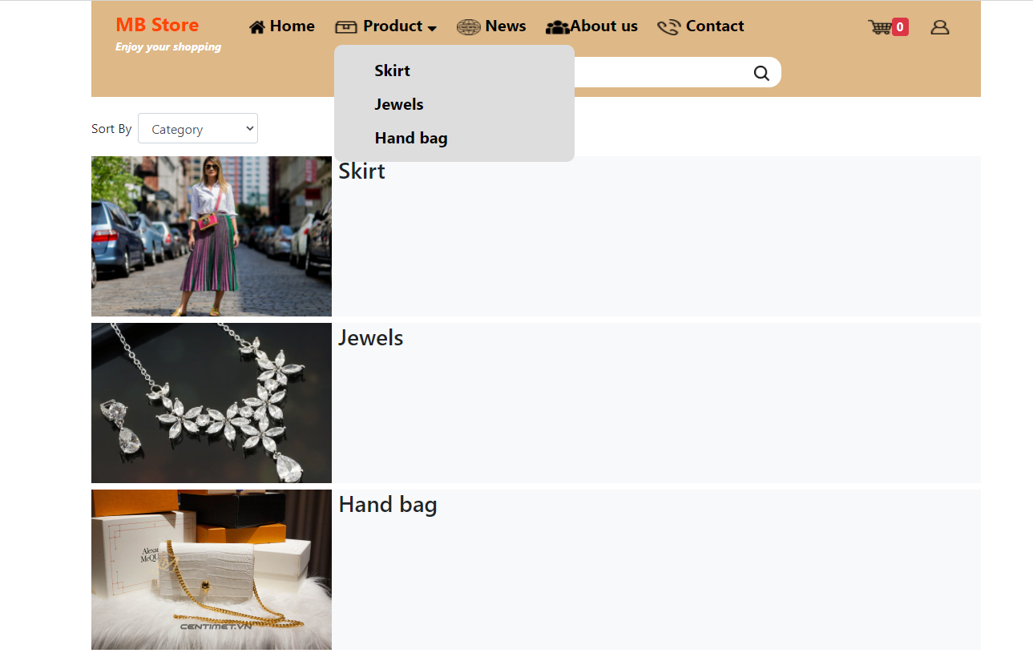

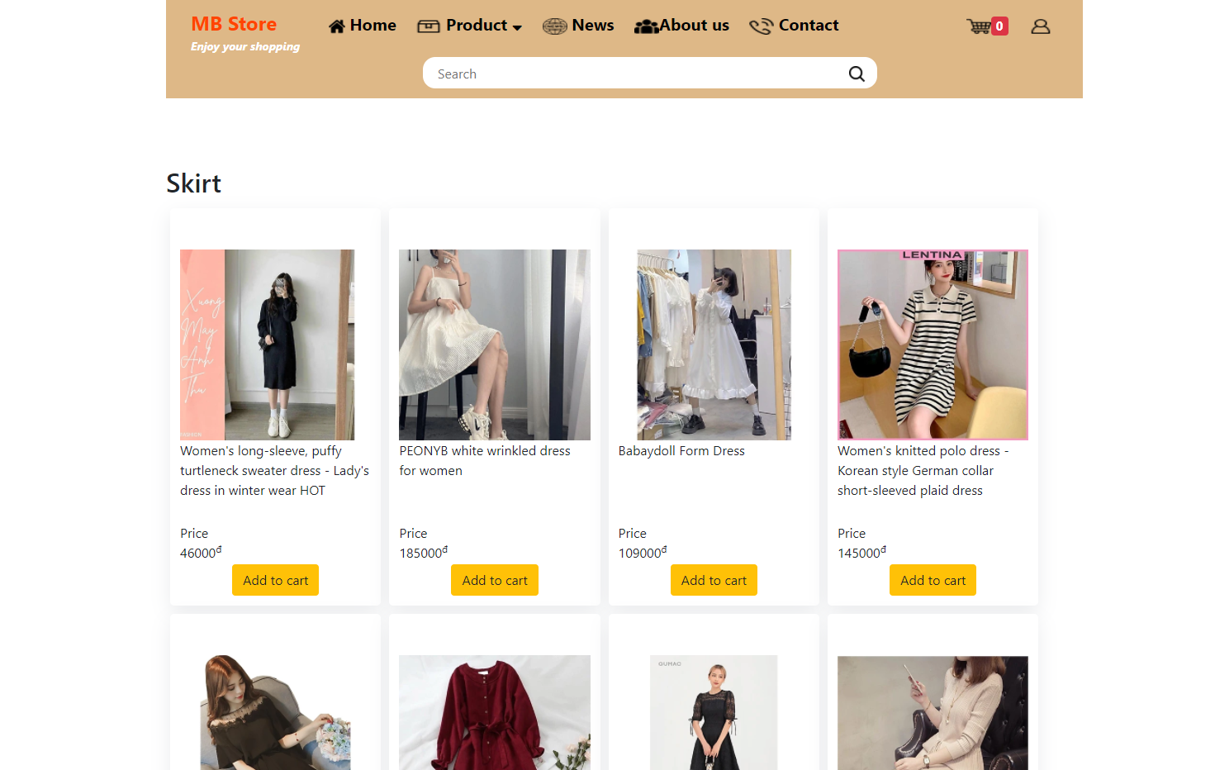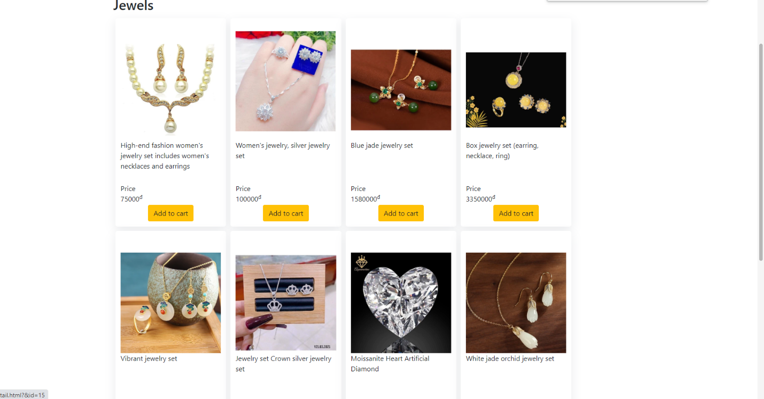

**3.About Us page**

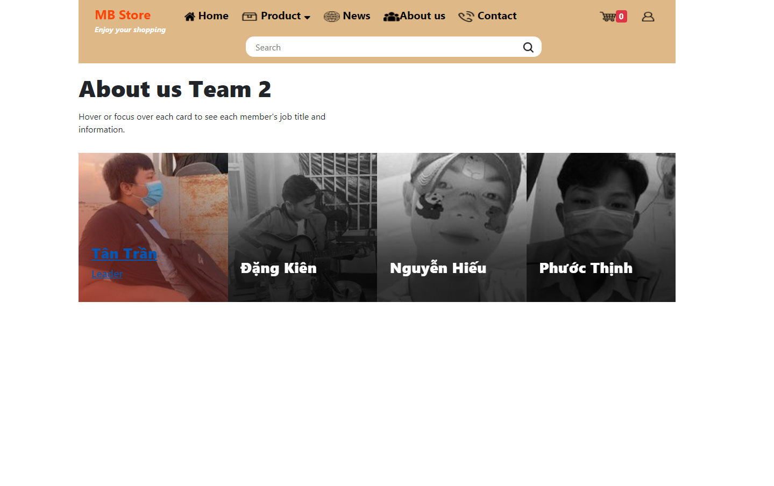

**4.Contact Us page**

The following snapshots illustrate the creation of MADAM's Boutique.COM contact us page:

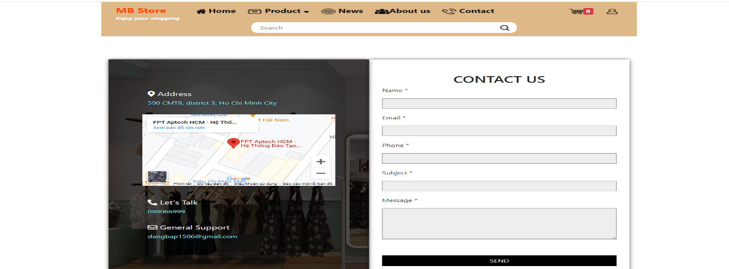

**5.Register and Login page**

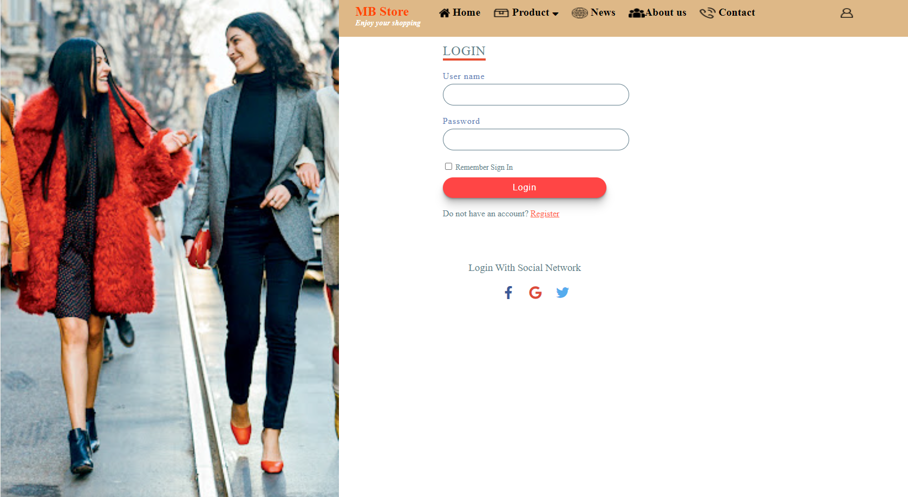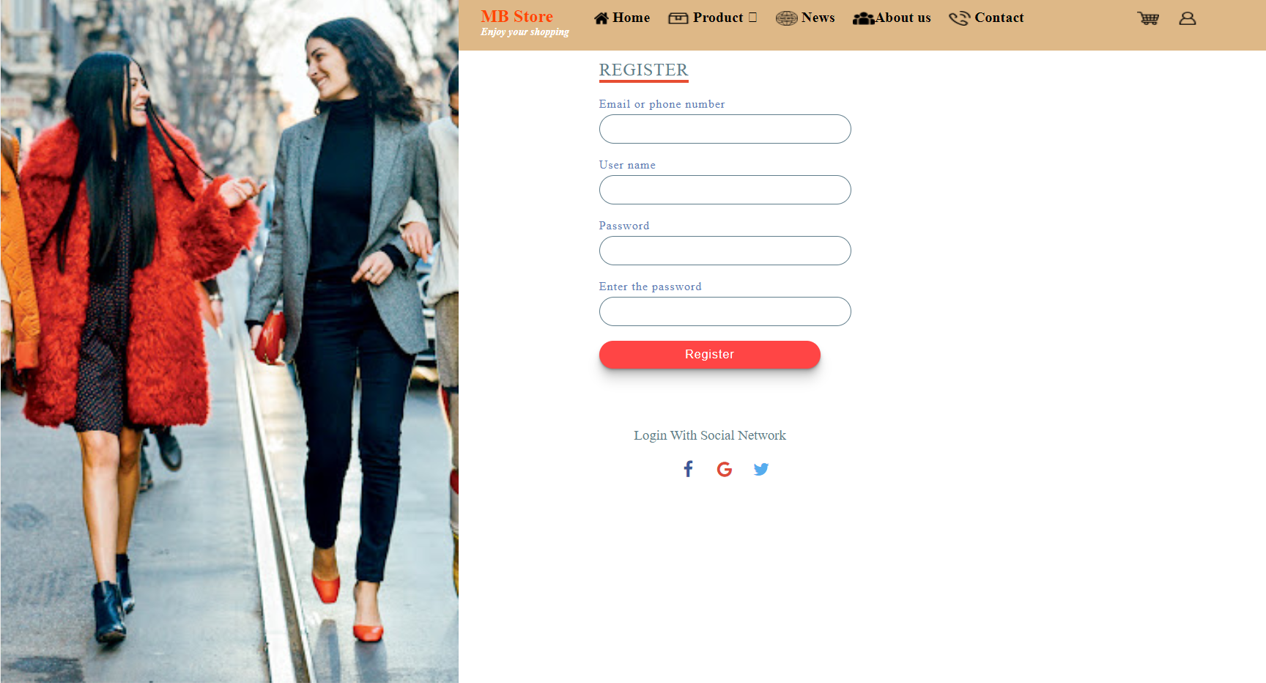

**6.Footer**

The following snapshot illustrates the creation of MADAM's Boutique.COM footer session

